CST 352 – Lecture 8 Devices
Wilsonville, Spring 2022

Ch 4, I/O, Hardware abstraction

Challenges for operating system:
- Many different types of devices
- Many different manufacturers/models for each type
- Interacting with devices while applications are running
- Knowing which devices are connected to the computer
- Presenting a common device interface to applications

Device Drivers
Examples device types:
Storage: Disk, Tape
Terminals: Display, Keyboard, Mouse
Printers
Network cards

Define device drivers for each type of device that abstracts the interface to the device
Specifically, what we need to do with or handle from the device
Write individual drivers for the various models for each type
Often the manufacturer will author the driver and make it available with the device

Device drivers run in the operating system
Still have to worry about security, so typically they will run more priveleged than an application, but less priveleged than the operating system kernel

Input/Output Architecture
Typically Operating Systems use a “memory-mapped” architecture
The device looks like its control registers and data are at memory addresses

Each device is controlled by a “controller” (hardware) and a “device driver” (software)
Controllers have registers for monitoring and controlling the device
Registers appear to be actual memory cells, with addresses in the CPU’s memory space
Each device controller is on a bus, and listens for read/write on their address space
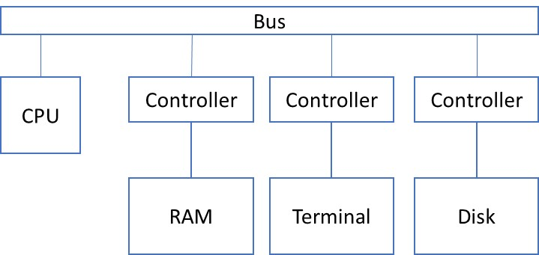
Common styles of controllers:
PIO – Programmed-I/O
Read/write one byte at a time through control registers
DMA – Direct Memory Access
Load operation-to-perform in control registers then tell it to go
Controller moves the memory in one direction or the other as needed
Requires actual RAM be allocated as a buffer

Devices use interrupts to signal when request completed

PIO Device

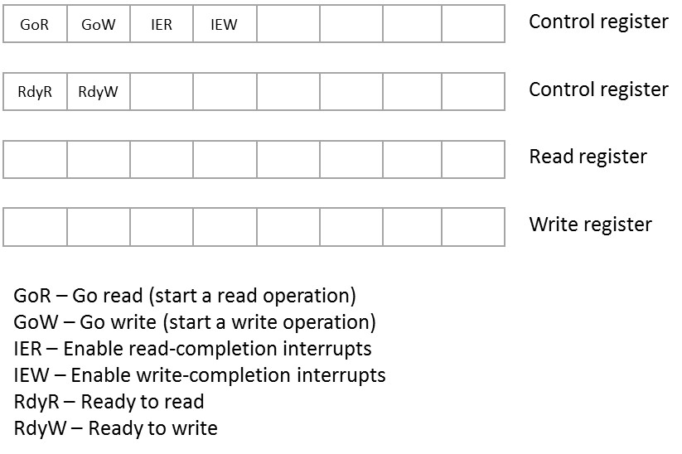

DMA Device

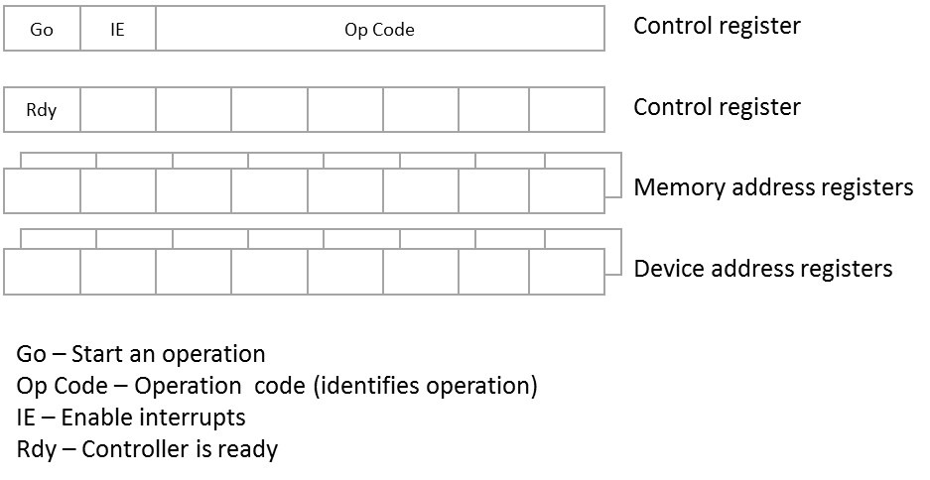

Device Identification and Discovery
For the operating system to talk with a device, the right device driver must load with…
Specific device identity
Interrupt configuration
Address of device i/o registers
Specific device settings

Early operating systems (UNIX) were statically linked to specific device drivers with all details included on exact device and configuration. Recompile to add new device!

Next evolution, probe routine in driver looked for specific device and discovered connection info. Still need to recompile in new drivers for new types of devices!

Today, meta drivers discover devices on a particular bus, e.g…
USB driver discovers devices on bus, identifies them, chooses device specific driver, etc.

Terminals
As an example of a complex device, simplified for applications…
Terminals are devices for human I/O
Show data to user, probably on a screen
Take input from user, probably through a keyboard

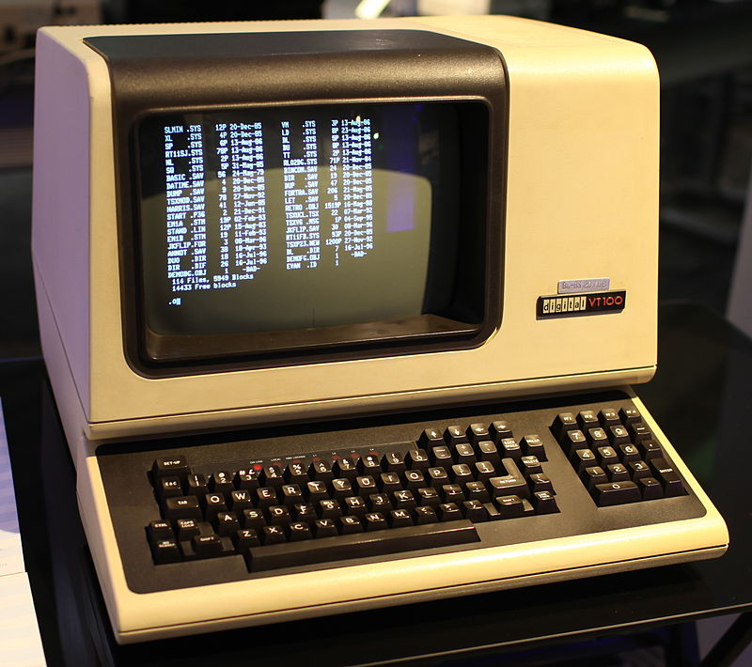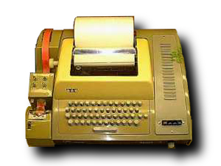
DEC VT100 (circa 1978) Teletype Model 33 ASR (circa 1963)

Terminals require…
Buffered I/O due to potential for computer or terminal to not be ready
Uses two queues: in from terminal, out to terminal
Code to process text in both directions to make sense to the human
“Dumb terminals” send/receive one character at a time
What if a user types characters then uses the backspace key?
Device driver to manage communication to the terminal
Terminal specific control codes
Serial line or network communication

OS design concern is how to allocate resources to each terminal
Use multiple threads for i/o with each terminal or a single thread for all terminals?
Many can lead to threads being blocked waiting frequently and wasting resources
One can lead to starvation of some terminals
Typically have an interrupt handler to pull data from serial line and drop in queue

Line Discipline handler…
To deal with backspace key, or other terminal editing of text, use a line buffer:
Characters are read in from terminal, one at a time, and placed in queue
When a carriage return is read, then characters are pulled and sent to “line queue”
Application then pulls a whole line from the completed queue

Echoing characters to the terminal can be done by the interrupt handler as well

Line Discipline handler can be separated from underlying terminal device to allow multiple devices to use same logic

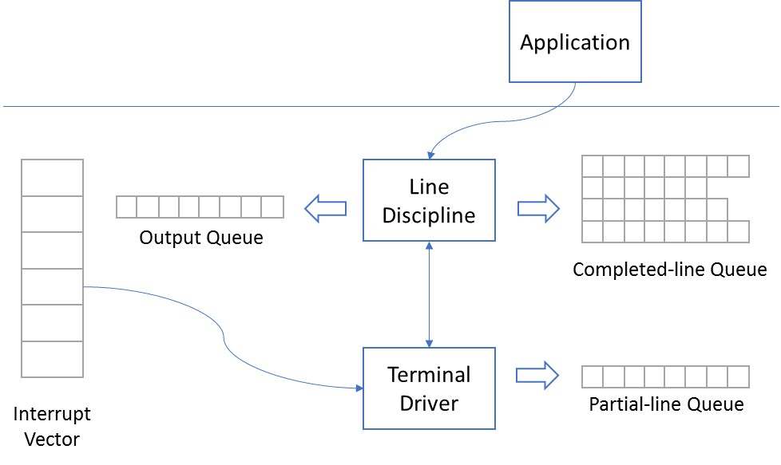

Terminal I/O is very much part of the operating system…
It’s actually built into the interrupt handler installed by the OS!

Modern “terminals” include a memory-mapped display, a keyboard and a mouse
Window managers in the OS abstract user operations and send events to applications

Other Common Devices
Network card drivers and protocol stack… more about this in a future lecture
Critical for OS is the performance of the network
Must move data quickly to keep up with common network speeds today
Data arrives async, even before the application is ready
Typically application protocol includes indication when ready for more

Storage devices
Already saw how file system works:
Disk drivers abstract the details of interacting with specific devices
File system on top, joins disks together into virtual file system

Booting
To complete the picture, how do we actually boot the computer?

BIOS (Basic Input/Output System) contains…
- Most basic read-only code / data required to power up the computer and devices
- Identifies the “boot device”, which is likely to be a storage device (e.g. disk)
- Finds the boot sector, loads it into memory and runs the code there
- Boot sector then loads the rest of the OS from disk and starts it going
- Since sectors are small (e.g. 512 bytes), the boot program has to be trivially simple, or has to be prepared to load additional sectors into memory

